UNIT-5 (PHP)
Program list
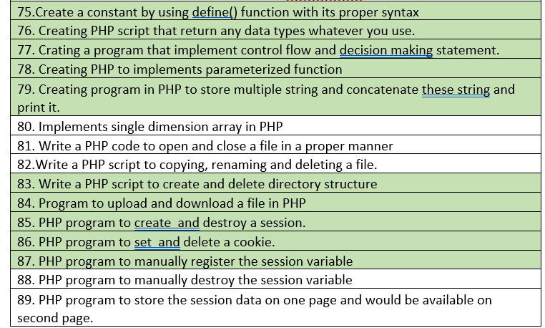

76. Creating PHP script that return any data types whatever you use.
77. Crating a program that implement control flow and decision making statement.
78. Creating PHP to implements parameterized function
79. Creating program in PHP to store multiple string and concatenate these string and print it.
80. Implements single dimension array in PHP
81. Write a PHP code to open and close a file in a proper manner
82.Write a PHP script to copying, renaming and deleting a file.
83. Write a PHP script to create and delete directory structure
84. Program to upload and download a file in PHP
85. PHP program to create and destroy a session.
86. PHP program to set and delete a cookie.
87. PHP program to manually register the session variable
88. PHP program to manually destroy the session variable
89. PHP program to store the session data on one page and would be available on second page.

Basic Syntax of PHP, Variables & Constants, Data Type, Operator & Expressions, Control flow and Decision making statements, Functions, Strings, Arrays,
Understanding file& directory, Opening and closing, a file, Copying, renaming and deleting a file,
working with directories, Creating and deleting folder, File Uploading &Downloading.
Introduction to Session Control, Session Functionality What is a Cookie, Setting Cookies with PHP. Using Cookies with Sessions, Deleting Cookies, Registering Session variables, Destroying the variables and Session.
76 to 79…….83 to 87

Simple php syntax example
<?php
// This is a simple PHP script

// Print a message to the console
echo "Hello, world!";

// Define a variable and assign a value
$name = "Alice";

// Print the value of the variable
echo "My name is $name.";

// Create an array
$fruits = array("apple", "banana", "orange");

// Print the third element of the array
echo $fruits[2];

// Create a function
function greet($name) {
echo "Hello, $name!";
}

// Call the function
greet("Bob");

?>
This code demonstrates the basic syntax of PHP, including:
- Comments: // for single-line comments and /* */ for multi-line comments.
- Printing: echo is used to print text to the console.
- Variables: Variables are declared using a $ sign followed by a name, and values are assigned using the = operator.
- Arrays: Arrays are created using the array() function or [] syntax.
- Functions: Functions are defined using the function keyword followed by a name and parentheses for parameters.
- Calling functions: Functions are called by using their name followed by parentheses with arguments.

"\n" in PHP is a newline character.
When you include "\n" within a string, it tells the interpreter to insert a new line at that specific point. This is useful for formatting text, creating multi-line strings, or separating different elements within a string.
Here are some common use cases for "\n":
1. Creating Multi-Line Strings:
PHP
$message = "This is the first line.\nThis is the second line.";
echo $message;
This will output:
This is the first line.
This is the second line.
2. Formatting Text:
PHP
$text = "Line 1\nLine 2\nLine 3";
echo $text;
This will output:
Line 1
Line 2
Line 3
3. Separating Elements in a String:
PHP
$data = "Name: John Doe\nAge: 30\nCity: New York";
echo $data;
This will output:
Name: John Doe
Age: 30
City: New York
In essence, "\n" is a way to control the appearance of text in your PHP output, making it more readable and structured.

PROGRAM 76

Creating PHP script that return any data types whatever you use.

<?php

// Function that returns different data types
function returnDifferentTypes($type) {
switch ($type) {
case 'string':
return "This is a string.";
case 'int':
return 42;
case 'float':
return 3.14;
case 'bool':
return true;
case 'array':
return [1, 2, 3];
case 'object':
return (object)['key' => 'value'];
default:
return "Unknown type.";
}
}

// Test the function with different types
echo returnDifferentTypes('string') . "\n";
echo returnDifferentTypes('int') . "\n";
echo returnDifferentTypes('float') . "\n";
echo returnDifferentTypes('bool') . "\n";

$arrayResult = returnDifferentTypes('array');
print_r($arrayResult);
echo "\n";

$objectResult = returnDifferentTypes('object');
print_r($objectResult);
echo "\n";

echo returnDifferentTypes('invalid') . "\n";

?>

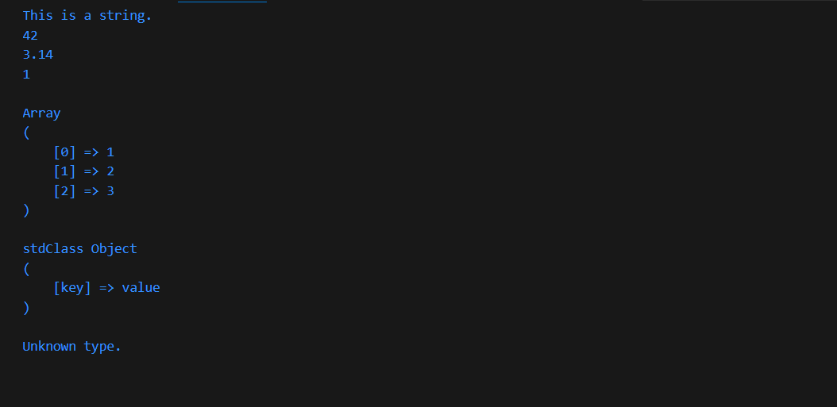

Purpose:
- The code defines a function named returnDifferentTypes() that returns different data types based on the input parameter type.
- It demonstrates how to create a flexible function that can handle various data types.
Code Breakdown:
- Function Definition:
  - function returnDifferentTypes($type): Declares a function named returnDifferentTypes that takes a single parameter type.
- Switch Statement:
  - switch ($type): Begins a switch statement that evaluates the value of the type parameter.
  - Cases:
    - case 'string': If type is "string", returns the string "This is a string.".
    - case 'int': If type is "int", returns the integer 42.
    - case 'float': If type is "float", returns the floating-point number 3.14.
    - case 'bool': If type is "bool", returns the boolean value true.
    - case 'array': If type is "array", returns an array containing the elements 1, 2, and 3.
    - case 'object': If type is "object", returns an object with a key named "key" and a value of "value".
    - default: If type doesn't match any of the above cases, returns the string "Unknown type.".
- Testing the Function:
  - echo returnDifferentTypes('string') . "\n";: Prints the result of calling returnDifferentTypes with "string" as the argument, followed by a newline.
  - Similar lines are used to test the function with other data types: "int", "float", "bool", "array", and "object".
  - $arrayResult = returnDifferentTypes('array'); print_r($arrayResult); echo "\n";: Calls the function with "array" as the argument, stores the result in $arrayResult, and prints the array using print_r.
  - $objectResult = returnDifferentTypes('object'); print_r($objectResult); echo "\n";: Similar to the previous line, but with "object" as the argument.
  - echo returnDifferentTypes('invalid') . "\n";: Tests the function with an invalid type "invalid" and prints the result.
Output:
The code will output the following:
This is a string.
42
3.14
1
Array (
[0] => 1
[1] => 2
[2] => 3
)
stdClass Object (
[key] => value
)
Unknown type.
Explanation of Output:
- Each line corresponds to the result of calling returnDifferentTypes with the respective data type.
- The output demonstrates how the function correctly returns different data types based on the input.
- The print_r function is used to print arrays and objects in a human-readable format.
This code provides a clear example of how to create a versatile function in PHP that can handle various data types and return appropriate values based on the input.

One more program along with explanation
Assuming returnDifferentTypes Implementation
PHP
<?php
function returnDifferentTypes($type) {
switch ($type) {
case 'array':
return ['value1', 'value2', 'value3'];
case 'object':
$obj = new stdClass();
$obj->property1 = 'value';
$obj->property2 = 123;
return $obj;
case 'invalid':
return 'Invalid type';
default:
return 'Unknown type';
}
}

$arrayResult = returnDifferentTypes('array');
print_r($arrayResult);
echo "\n";

$objectResult = returnDifferentTypes('object');
print_r($objectResult);
echo "\n";

echo returnDifferentTypes('invalid') . "\n";
?>
Explanation of Corrected Code:
- returnDifferentTypes Implementation: The returnDifferentTypes function now includes a switch statement to handle different input types:
  - For 'array', it returns a sample array.
  - For 'object', it creates a new object with properties and returns it.
  - For 'invalid', it returns a string indicating invalid input.
  - For other unknown types, it returns a string indicating an unknown type.
Output: The code will output the following:
Array (
[0] => value1
[1] => value2
[2] => value3
)

stdClass Object (
[property1] => value
[property2] => 123
)

Invalid type
This corrected code demonstrates how to properly define and use the returnDifferentTypes function to return different types of values based on the input.

PROGRAM 77
Creating a program that implement control flow and decision-making statement in php.
<?php
// Control Flow with if-else statements
$age = 25;

if ($age < 18) {
echo "You are under 18 years old. You cannot vote.\n";
}
elseif ($age >= 18 && $age < 65) {
echo "You are eligible to vote.\n";
}
else {
echo "You are 65 or older. You can still vote!\n";
}

// Control Flow with a switch statement
$dayOfWeek = 3;

switch ($dayOfWeek) {
case 1:
echo "Today is Monday.\n";
break;
case 2:
echo "Today is Tuesday.\n";
break;
case 3:
echo "Today is Wednesday.\n";
break;
case 4:
echo "Today is Thursday.\n";
break;
case 5:
echo "Today is Friday.\n";
break;
default:
echo "It's the weekend!\n";
}

// Control Flow with a while loop
$num = 1;
while ($num <= 5) {
echo "While loop iteration: $num\n";
$num++;
}

// Control Flow with a for loop
for ($i = 1; $i <= 5; $i++) {
echo "For loop iteration: $i\n";
}

?>

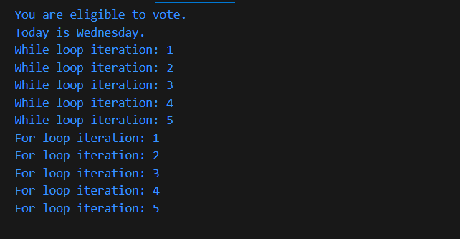

PROGRAM 78

Creating PHP script to implements parameterized function.

<?php
// Define a parameterized function
function greet($name) {
echo "Hello, $name!\n";
}

// Call the function with different arguments
greet("Rajat");
greet("Ani");
greet("Aditya");

?>

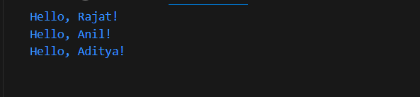

PROGRAM 79
Creating program in PHP to store multiple string and concatenate these string and print it.

<?php

// Define multiple strings
$string1 = "Hello, ";
$string2 = "World!";
$string3 = "This is a PHP program.";

// Concatenate the strings
$concatenatedString = $string1 . $string2 . ' ' . $string3;

// Print the concatenated result
echo $concatenatedString;

?>

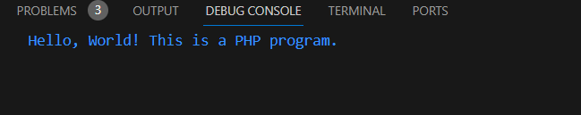

PROGRAM 80
Implement single dimension array in PHP.
<?php
// Create a single-dimensional array
$fruits = array("apple", "banana", "cherry", "date", "fig");

// Access and print elements from the array
echo "Fruits at index 0: " . $fruits[0] . "\n"; // Accessing the first element
echo "Fruits at index 2: " . $fruits[2] . "\n"; // Accessing the third element

// Add elements to the array
$fruits[] = "grape"; // Adding a new element to the end of the array
$fruits[6] = "kiwi"; // Adding an element with a specific index

// Print the entire array
echo "All fruits: " . implode(", ", $fruits) . "\n";

// Modify an element
$fruits[1] = "blueberry"; // Modifying the second element

// Remove an element
unset($fruits[3]); // Removing the fourth element

// Print the modified array
echo "Modified fruits: " . implode(", ", $fruits) . "\n";

?>

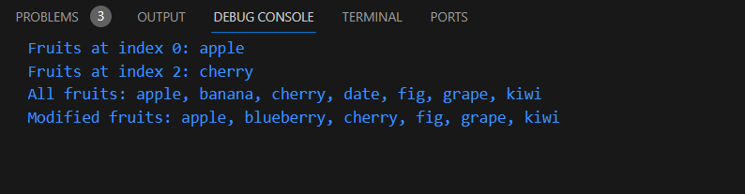

PROGRAM 81

Write a PHP code to open and close a file in a proper manner.

<?php

$filename = "example.txt"; // Replace with the name of your file

// Open the file for reading
$file = fopen($filename, "r");

if ($file) {
// Read and display the content of the file
while (!feof($file)) {
$line = fgets($file);
echo $line;
}

// Close the file
fclose($file);
} else {
echo "Failed to open the file.";
}

?>

PROGRAM 82
Write a PHP script to copying, renaming and deleting a file.

<?php
// Define the source and target file paths
$sourceFile = "source.txt";
$targetFile = "target.txt";

// Copy the source file to the target file
if (copy($sourceFile, $targetFile)) {
echo "File copied successfully.\n";
} else {
echo "Failed to copy the file.\n";
}

// Rename the target file
$newName = "renamed_target.txt";
if (rename($targetFile, $newName)) {
echo "File renamed successfully.\n";
} else {
echo "Failed to rename the file.\n";
}

// Delete the source file and the renamed target file
if (unlink($sourceFile)) {
echo "Source file deleted successfully.\n";
} else {
echo "Failed to delete the source file.\n";
}

if (unlink($newName)) {
echo "Renamed target file deleted successfully.\n";
} else {
echo "Failed to delete the renamed target file.\n";
}

?>

PROGRAM 83

Write a PHP script to create and delete directory structure.

<?php

// Create a directory
$dirName = "my_directory";

if (mkdir($dirName)) {
echo "Directory '$dirName' created successfully.\n";
} else {
echo "Failed to create directory '$dirName'.\n";
}

// Create subdirectories
$subDirName = "$dirName/subdirectory";

if (mkdir($subDirName, 0777, true)) {
echo "Subdirectory '$subDirName' created successfully.\n";
} else {
echo "Failed to create subdirectory '$subDirName'.\n";
}

// List the directory contents
echo "Directory contents:\n";
$dirContents = scandir($dirName);
foreach ($dirContents as $item) {
if ($item != "." && $item != "..") {
echo $item . "\n";
}
}

// Delete the subdirectory and directory
if (rmdir($subDirName)) {
echo "Subdirectory '$subDirName' deleted successfully.\n";
} else {
echo "Failed to delete subdirectory '$subDirName'.\n";
}

if (rmdir($dirName)) {
echo "Directory '$dirName' deleted successfully.\n";
} else {
echo "Failed to delete directory '$dirName'.\n";
}

?>

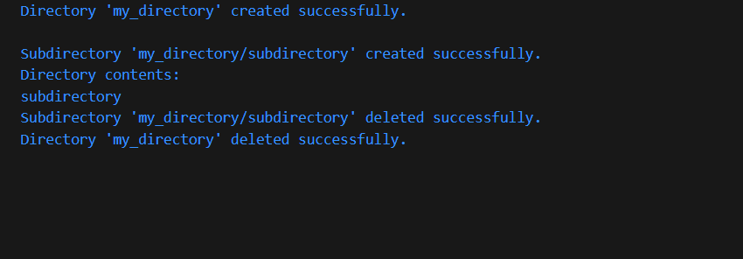

PROGRAM 84
Program to upload and download a file in PHP.
Create an HTML form for file upload (upload.html):
<!DOCTYPE html>
<html>
<head>
<title>File Upload</title>
</head>
<body>
<h2>Upload a File</h2>
<form action="upload.php" method="post" enctype="multipart/form-data">
<input type="file" name="fileToUpload" id="fileToUpload">
<input type="submit" value="Upload File" name="submit">
</form>
</body>
</html>

Create a PHP script to handle the file upload (upload.php):
<?php
if ($_SERVER["REQUEST_METHOD"] == "POST" && isset($_FILES["fileToUpload"])) {
$targetDir = "uploads/";
$targetFile = $targetDir . basename($_FILES["fileToUpload"]["name"]);

if (move_uploaded_file($_FILES["fileToUpload"]["tmp_name"], $targetFile)) {
echo "The file " . basename($_FILES["fileToUpload"]["name"]) . " has been uploaded.";
} else {
echo "Sorry, there was an error uploading your file.";
}
}
?>

File Download

To download a file, you can create a link or button that, when clicked, triggers the download. Here's an example:

<!DOCTYPE html>
<html>
<head>
<title>File Download</title>
</head>
<body>
<h2>Download a File</h2>
<a href="downloads/sample.txt" download>Download Sample File</a>
</body>
</html>

PROGRAM 85
PHP program to create and destroy a session.

Create a Session:

<?php
// Start a new or resume the existing session
session_start();

// Set session variables
$_SESSION['username'] = 'john_doe';
$_SESSION['user_id'] = 123;

echo 'Session has been created with username: ' . $_SESSION['username'] . ' and user ID: ' . $_SESSION['user_id'];
?>

Destroy a Session:

<?php
// Start or resume the session
session_start();

// Clear all session data
session_unset();

// Destroy the session
session_destroy();

echo 'Session has been destroyed.';
?>
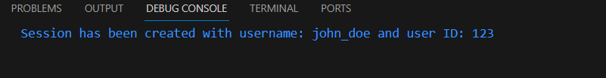

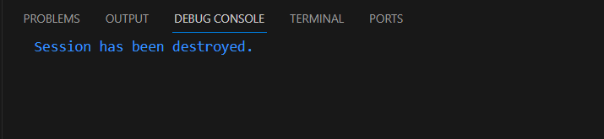

PROGRAM 86
PHP program to set and delete a cookie.

Set a Cookie:

<?php
// Set a cookie with a name, value, and optional expiration time (in seconds)
$cookieName = "user";
$cookieValue = "john_doe";
$expirationTime = time() + 3600; // Cookie expires in 1 hour

setcookie($cookieName, $cookieValue, $expirationTime, "/");
echo "Cookie '$cookieName' has been set with value '$cookieValue'";
?>

Delete a Cookie:

<?php
// Set a cookie to delete (with an expiration time in the past)
$cookieName = "user";

// Set the cookie's expiration time to a time in the past (e.g., one hour ago)
$expirationTime = time() - 3600; // Cookie expired one hour ago

setcookie($cookieName, "", $expirationTime, "/");
echo "Cookie '$cookieName' has been deleted";
?>
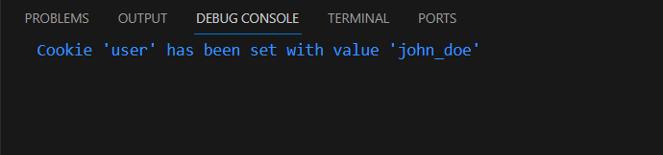

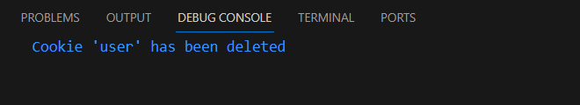

PROGRAM 87
PHP program to manually register the session variable.

<?php
// Start or resume the session
session_start();

// Manually register a session variable
$_SESSION['username'] = 'john_doe';

// Access and print the session variable
echo 'Session variable username: ' . $_SESSION['username'];
?>

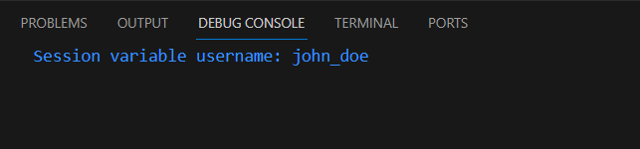

PROGRAM 88

PHP program to manually destroy the session variable.

<?php
// Start or resume the session
session_start();

// Manually register a session variable
$_SESSION['username'] = 'john_doe';

// Access and print the session variable
echo 'Session variable username: ' . $_SESSION['username'];
?>

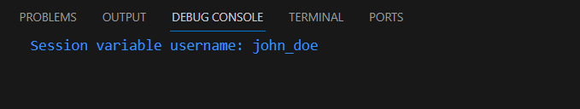

PROGRAM 89

PHP program to store the session data on one page and would be available on second page.

First Page (store_session_data.php):

<?php
// Start or resume the session
session_start();

// Store data in the session
$_SESSION['username'] = 'john_doe';
$_SESSION['user_id'] = 123;

echo 'Session data has been stored.';
?>

Second Page (retrieve_session_data.php):

<?php
// Start or resume the session
session_start();

// Access and print the session data
if (isset($_SESSION['username']) && isset($_SESSION['user_id'])) {
echo 'Username: ' . $_SESSION['username'] . '<br>';
echo 'User ID: ' . $_SESSION['user_id'];
} else {
echo 'Session data not found.';
}
?>

